AutoCert using Custom Studios and Actions TOI
Shai Perretz (shaip@arista.com)
28.9.2025
v1.0.1

AutoCert using Custom Studios and Actions TOI 1
Prerequisites: 2
Download and import the custom studio and actions 2
Download The EST Root CA from AGNI 3
Download The RadSec Root CA from AGNI 3
Create an Action Bundle 4
Applying the Action Bundle 11
Configure The Studio 13
Example Generated configuration: 18
Appendix/ Issues 19
Questions 20

Prerequisites:
- Download certificates to the local directory on your laptop.
- Importing the custom studio, actions and certificates and creating an action bundle
- For new switches where CVP is already configured with prerequisite, you can skip directly to section: Applying the Action Bundle.
- Copying the certificates from the EST/RadSec server can be done manually using many ways such as scp/ssh/terminal.
- If you already uploaded the certificates and created a self signed certificate you can skip directly to section: “Configure the Studio”

Download and import the custom studio and actions

- Download the package, this includes both custom actions and the custom studio.
pkg-est-certmgt_1.1.1.tar
- Install the package using CVP -> settings - > packaging -> install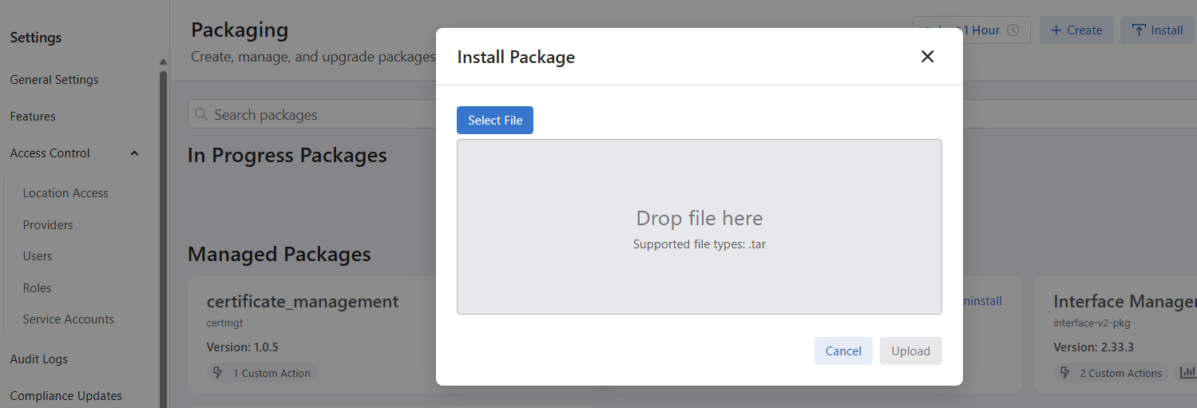

Download The EST Root CA from AGNI
- Go to AGNI -> Concourse, install the AGNI EST application and download the EST CA certificate.
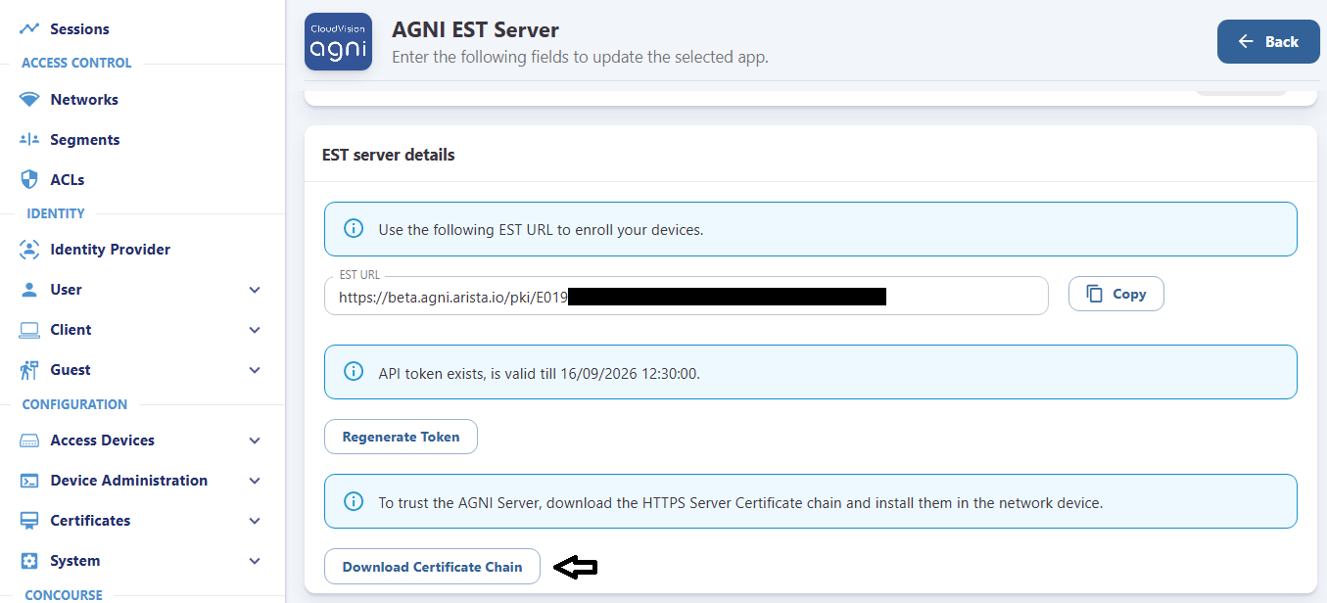

Download The RadSec Root CA from AGNI
- Go to AGNI -> setting and download the EST CA certificate
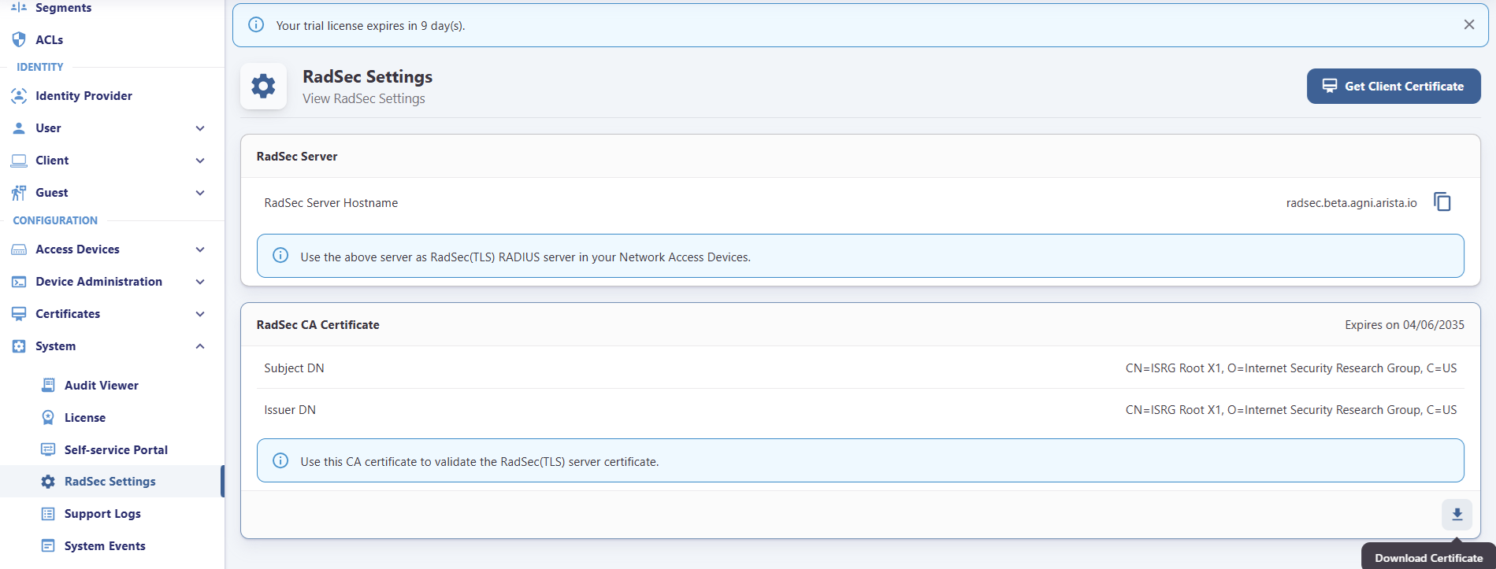

Create an Action Bundle
- The Action Bundle will be used to create a self-signed certificate and for each switch. It will also push both Radsec and EST CAs into the switches certificate directory
- The Action Bundle should include 4 actions:
  - Set configuration
  - Create self signed certificate
  - Push certificate with the Radsec CA
  - Push Certificate with the EST CA
- Example of creating the bundle:
  - CVP -> Provisioning -> Action Bundles -> new Action Bundle

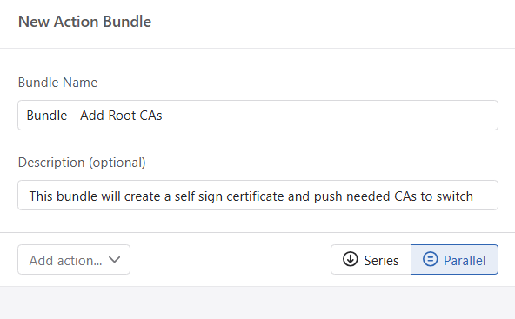

  - Click on the pencil sign to edit the newly created bundle

  - Add action bundle (1) - set configuration
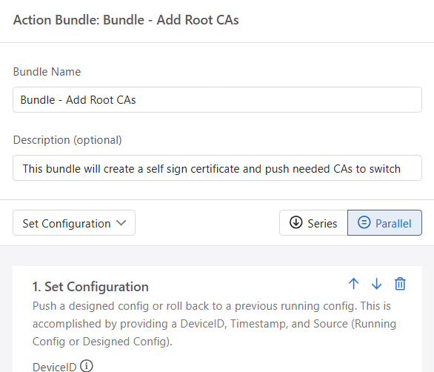

  - Add action bundle (2) - Self-signed certificate/key creation vx.y.z.
    - Copy both file names of the certificate and key, we will need to use it later in the custom studio details.
    - deviceID select: ”provide via template”
    - Make sure to change the default values as needed
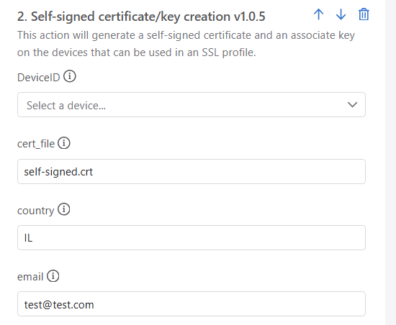

  - Add action bundle (3) - Push CA Certificate to switch vX.Y.Z
    - This action will be used to push the EST certificate into the switch.
    - Certificate must be in PEM format.
    - device ID select: ”provide via template”.
    - Filename: temporary location for the certificate file.
*To avoid syntax errors, it is recommended to use the certificate filename originally received from AGNI for the Radec default is: “AGNI_https_server_cert_chain.pem”
    - Open the downloaded EST certificate chain using notepad and copy it as one line. The script will format it back with newlines.
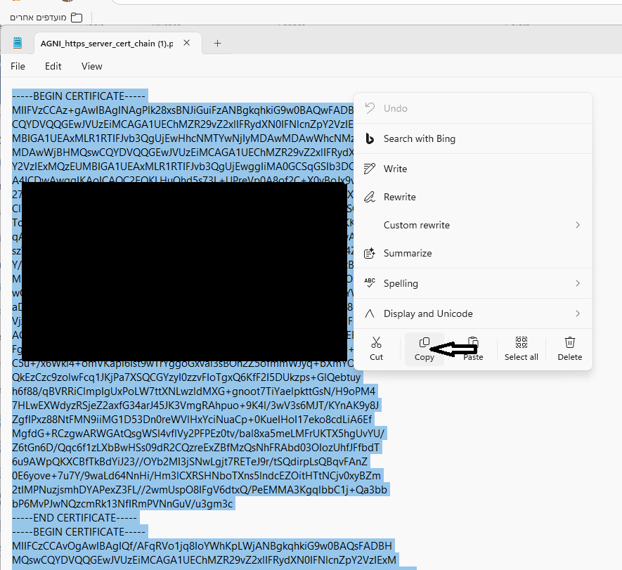
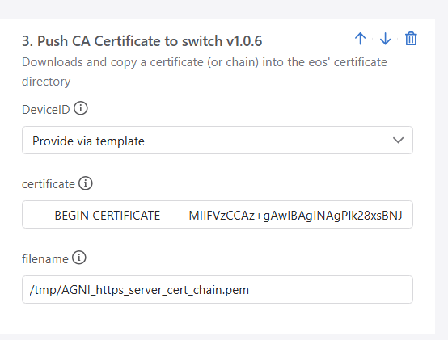

  - Add action bundle (4) - Push CA Certificate to switch vX.Y.Z
    - This action will be used to push the RadSec certificate into the switch.
    - Certificate must be in PEM format.
*It is the same action and process as the latest, the only difference is the certificate and filename.
    - device ID select: ”provide via template”.
    - Filename: temporary location for the certificate file.
*To avoid syntax errors, it is recommended to use the certificate filename originally received from AGNI for the Radec default is: “radsec_ca_certificate.pem”
    - Open the downloaded RadSec certificate chain using notepad and copy it as one line. The script will format it back with newlines.
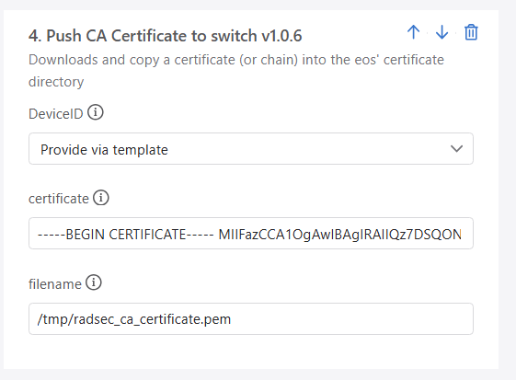

3.7 Click Save to save the bundle
3.8 Create a new Template and add the bundle into the temple
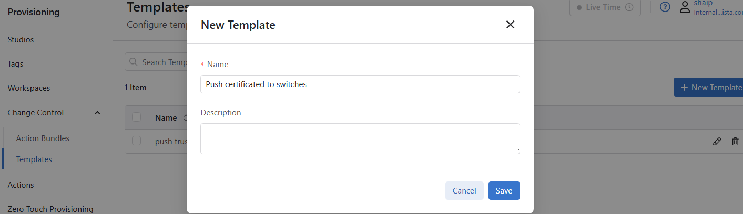

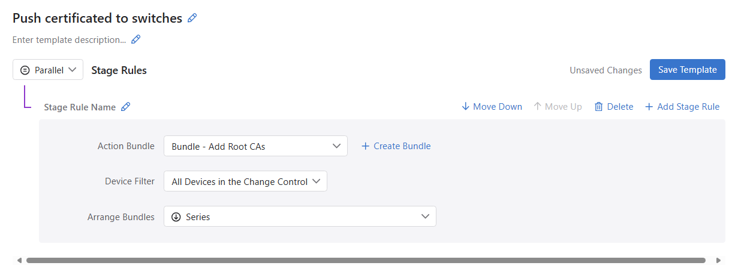

Applying the Action Bundle
- ** Note that the action will overwrite any existing certificates using the same filename including any self signed certificates already existing on the switch. Make sure the filenames are not in use.
- CVP -> provisioning -> change control -> create change control
- Change the name for example: “push certificate to new switches”
- add action -> “Set Configuration”
- choose the devices you want to push onto the certificates. Make sure you only choose the desired devices as this will override existing configuration.
- Click “Add to change control”.
You should now see the devices listed on the change control.
- Click “Apply Template” and select the template created.
You should now see 4 actions per device.
Click “Review and Approve” to apply the config.

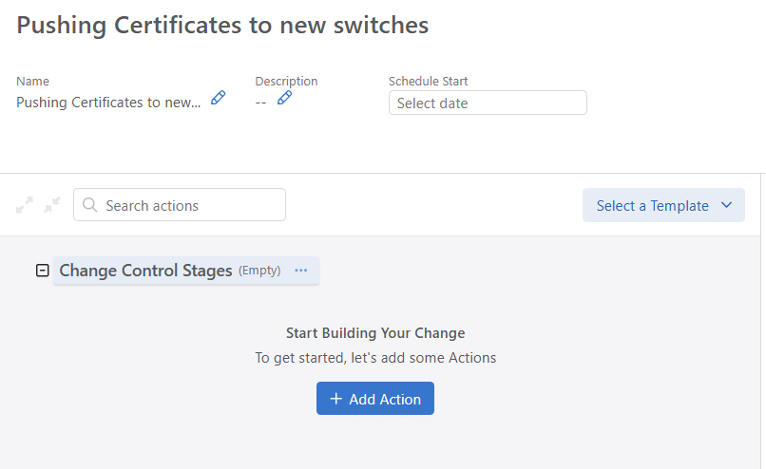
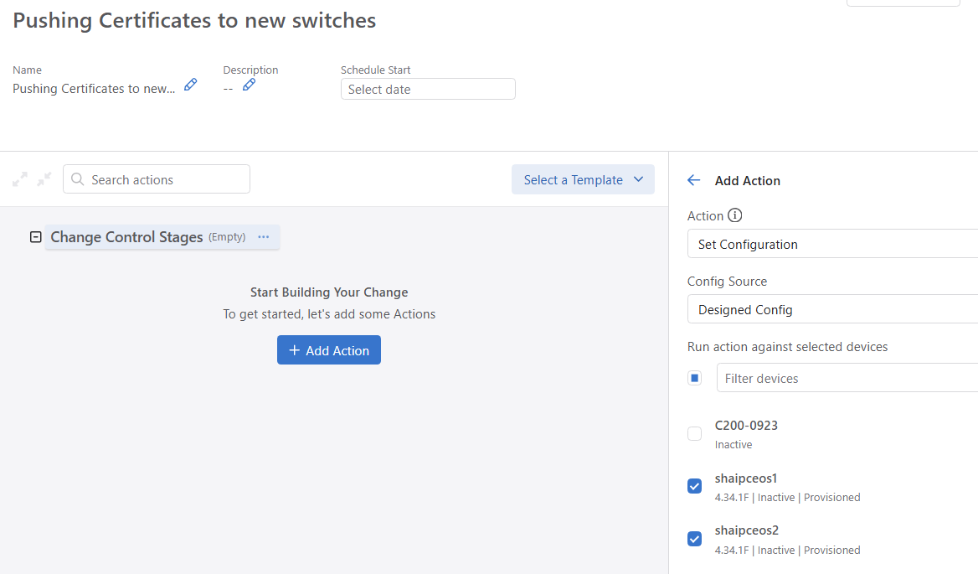

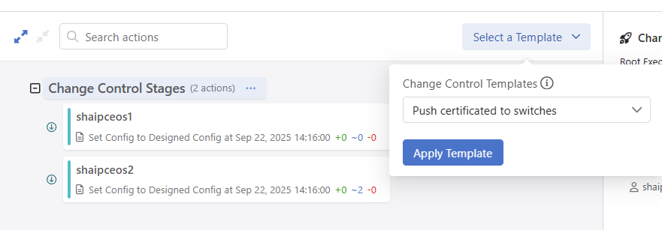

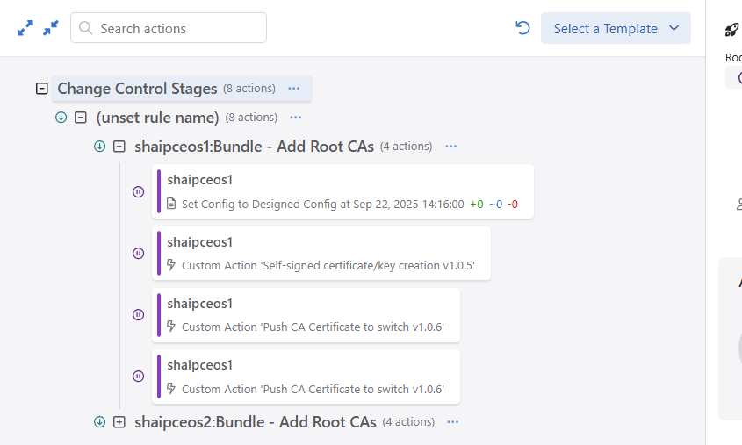

Configure The Studio
- CVP -> provisioning -> studios -> “Configure AGNI EST vX.Y.Z”
- Create a new workspace.
- Device selection: select the devices you want to apply the configuration.
You can leave it as “all devices” and filter the exact devices by adding them inside the studio.
- Apply devices: choose the devices you want to manage.
4.1 All devices using the same configuration should be in the same line.
4.2 devices using different server details, or different certificate properties use separated lines.
- Add General dot1x/radius config:
5.1 Yes - If you want the studio to build basic radius and dot1x configuration.
This configuration will use the auto generated certificate for the Radsec.
5.1 No - For more advanced radius/dot1x configuration please use “authentication” and “campus L3” built-in studios
- certificate properties: Click “view” to enter the configuration.
  - Make sure you edit all the configurations according to your company policies.
  - Common-name: should be left blank so that the switch’s mac will be used. This is required for AGNI to first identify the device.
  - auto cert profile name: the name of the profile will be the name of the certificate file automatically generated by EST. this certificate name can be used later for Radsec configuration.
  - self sign certificate file name: use the filename pre-created on the switch.
  - self sign key file name: use the filename pre-created on the switch.
- EST server details: Click “view” to enter the configuration.
  - est server url: To see the est url go to AGNI -> CONCOURSE -> go to AGNI-> concurse -> EST server details for example: https://beta.agni.arista.io/pki/xxx-xxxx-xxxxxxxx
  - est ssl server profile name name of the ssl profile to configure on the switch for example: agni-server
  - radius server hostname: hostname of the radius server . To see the hostname go to AGNI -> System -> RadSec Settings for example: radsec.beta.agni.arista.io
  - radius ssl server profile name: the name of the ssl profile used to authenticate the radisec server certificate for example: agni-server-radsec
  - radius server group name: the name of the ssl profile used to authenticate the radisec server certificate for example : agni-server-group
  - radius source interface: optionally specify an interface for radius traffic originating from the switch.
- Tokens:
  - AGNI EST Server -> click on re/generate Token.
  - This token is shown only once on the EST server, if you regenerate the token you cannot use the previous token, so all switches will need to be updated with the new token.
  - enrollment token: token used to authenticate enrollment process with the EST server
  - reenrollment token: token used to authenticate reenrollment process with the EST server.
  - In the current AGNI EST implementation reenrollment token and reenrollment token are the same
  - You can copy the token as is, or copy already encrypted password by adding 7/8a “7 xxxxxx” or “8a xxxx” for an already unfocused password.

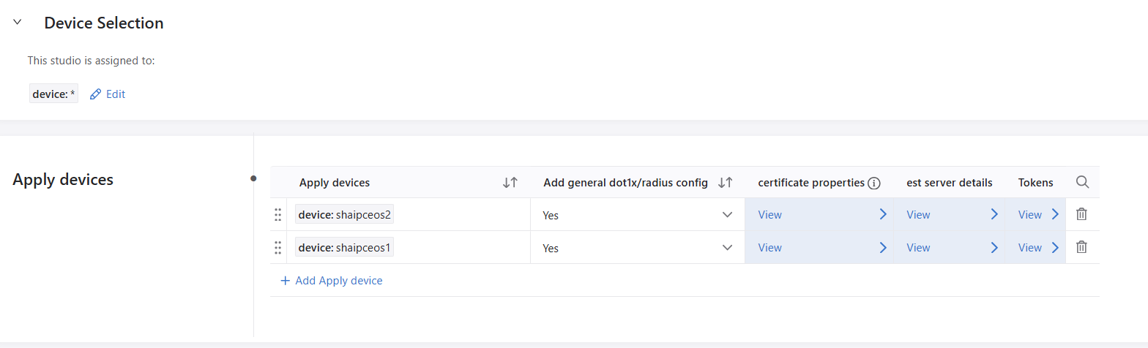

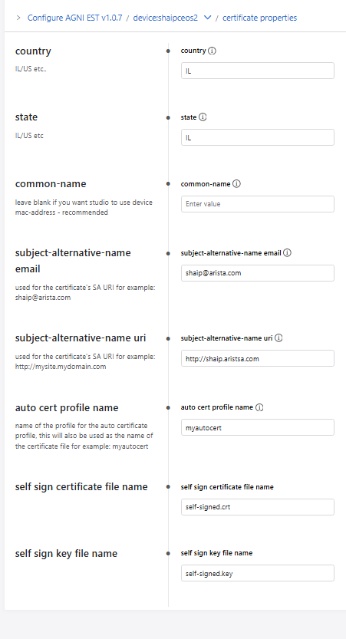
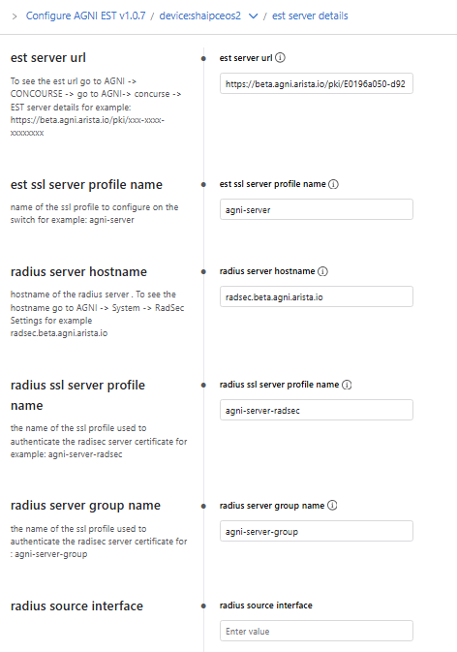
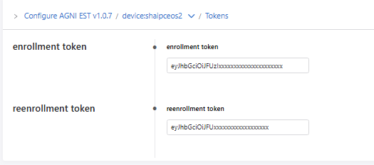
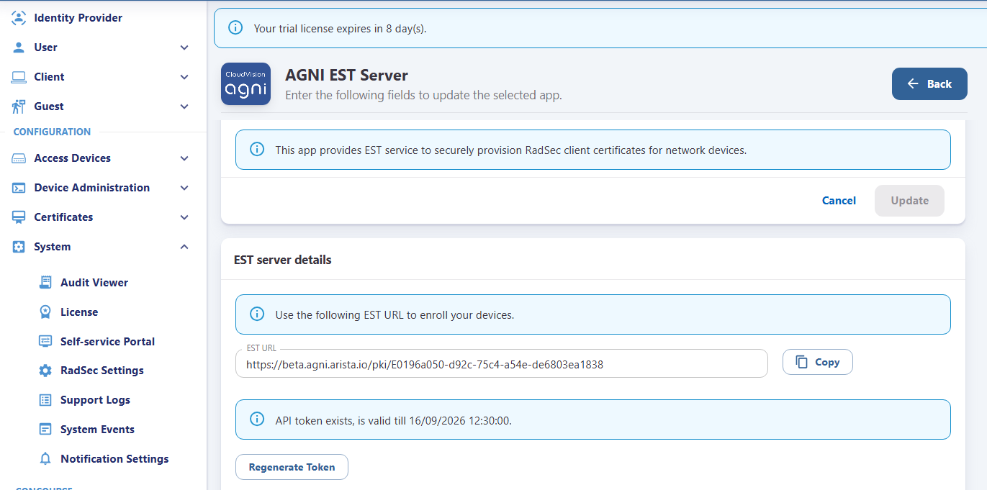

Example Generated configuration:
management security
auto-certificate protocol est agni-server
server url https://beta.agni.arista.io/pki/E0196a0xxxxxxx
server ssl profile agni-server
credentials enroll token 7 0603160B444C2E1A0C33xxxxx
credentials re-enroll token 7 0603160B444C2E1A0C381Bxxxxx
!
auto-certificate profile myautocert
key self-signed.key
parameters distinguished-name common-name 00:1c:73:f9:d1:19
parameters distinguished-name country IL
parameters distinguished-name state IL
parameters subject-alternative-name ip 172.20.20.4
parameters subject-alternative-name dns shaipceos1
parameters subject-alternative-name email shaip@arista.com
parameters subject-alternative-name uri http://shaip.arista.com
protocol instance agni-server
!
ssl profile agni-server
certificate self-signed.crt key self-signed.key
trust certificate AGNI_https_server_cert_chain.pem
!
ssl profile agni-server-radsec
certificate auto-certificate myautocert
trust certificate radsec_ca_certificate.pem
!
!
radius-server host radsec.beta.agni.arista.io tls ssl-profile agni-server-radsec
aaa group server radius agni-server-group
server radsec.beta.agni.arista.io tls
!
aaa authentication dot1x default group agni-server-group
aaa accounting dot1x default start-stop group agni-server-group
!
dot1x system-auth-control
dot1x protocol lldp bypass
dot1x dynamic-authorization
dot1x
radius av-pair service-type
radius av-pair lldp system-name
radius av-pair lldp system-description

Appendix/ Issues

Questions

Contact shaip@arista.com for any questions.

